
Contact: Tricia McGough, TW Marketing
+1.254.383.9700; tricia@twmarketing.net

FOR IMMEDIATE RELEASE

Visit StratEdge at International Microwave Symposium (IMS) 2021 Booth 1014
Photo available at: www.stratedge.com/semiconductor-packaging.png

StratEdge High-performance Semiconductor Packages to be on Display at IMS2021, June 8-9, in Booth 1014

Removes the heat from high-performance packages
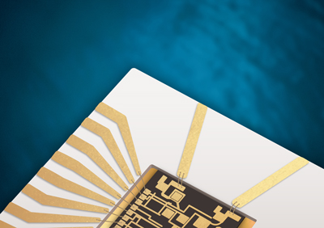
Santee, Calif. — June 7, 2021 — StratEdge Corporation, leader in the design and production of high-performance semiconductor packages for microwave, millimeter-wave, and high-power devices, will display its thermally-efficient line of post-fired and molded ceramic semiconductor packages in Booth 1014 at the International Microwave Symposium (IMS), being held in Atlanta, GA, from June 8-9. StratEdge packages operate from DC to 63+ GHz and dissipate heat from compound semiconductor devices such as gallium nitride (GaN), gallium arsenide (GaAs), and silicon carbide (SiC). These packages enable compound semiconductor devices to meet the critical requirements of markets such as telecom, mixed signal, VSAT, broadband wireless, satellite, military, test and measurement, automotive, and down-hole.

Also join StratEdge for the Industry Talk series taking place on Monday, June 21, in the IMS virtual environment. Casey Krawiec will be presenting "Eutectic Die Attach for High Power GaN Devices," at 11:00 a.m. and answering questions live.

"StratEdge is excited to be exhibiting at a live show again. Our experts are thrilled to discuss your packaging needs in person," said Casey Krawiec, VP of global sales at StratEdge. "We manufacture our packages to exacting specifications, using hardened or post-fired ceramics that don't shrink, substrates that dissipate heat, and electrical transition designs for exceptionally low electrical losses. To further ensure optimized performance, StratEdge Assembly Services can package your devices in our new cleanroom, which is equipped with the latest precision wire bonding and die attach systems."
Visit StratEdge at International Microwave Symposium (IMS) 2021, Booth 1014, June 8-9, Atlanta.
For more information about StratEdge call (858) 569-5000, email info@stratedge.com, or visit our website at www.stratedge.com.

About StratEdge
StratEdge Corporation, founded in 1992, designs, manufactures, and provides assembly services for a complete line of high-frequency and high-power semiconductor packages operating from DC to 63+ GHz. StratEdge offers post-fired ceramic, low-cost molded ceramic, and ceramic QFN packages, and specializes in packages for extremely demanding gallium arsenide (GaAs) and gallium nitride (GaN) devices. Markets served include telecom for 5G, VSAT, broadband wireless, satellite, military, test and measurement, automotive, clean energy, and down-hole. All packages are lead-free and most meet RoHS and WEEE standards. StratEdge is ITAR registered and an ISO 9001:2015 certified facility located in Santee, California, near San Diego.
###
For more information contact:

Casey Krawiec
StratEdge Corporation
9424 Abraham Way, Santee, CA 92071
Email: c.krawiec@stratedge.com
Phone: +1.858.569.5000

Tricia McGough
TW Marketing (agency)
Email: tricia@twmarketing.net
Phone: +1.254.383.9700

