Contact: Tricia McGough, AR Marketing, Inc.
+1.254.383.9700; tricia@armarketinginc.com

FOR IMMEDIATE RELEASE
Photo available at: https://www.stratedge.com/rf-packaging-expanded.png

StratEdge Expands Production Capacity of its RF Packaging Line
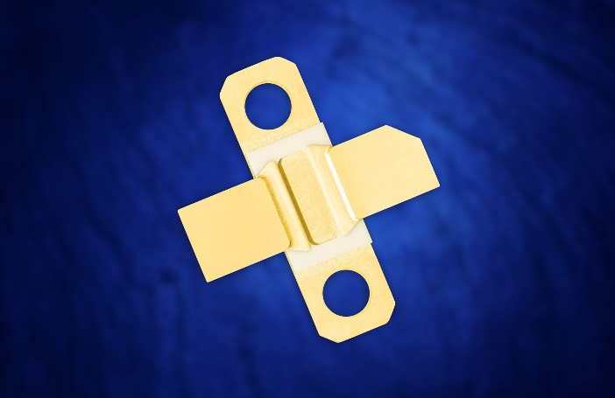
Packages support the 5G infrastructure build-out
Santee, Calif — June 9, 2020 — StratEdge Corporation, leader in the design, production, and assembly of high-frequency and high-power semiconductor packages for microwave, millimeter-wave, and high-speed digital devices, announces the expansion of its production line for building ceramic and molded ceramic packages to support 5G infrastructure demands. The packages, most often used to protect high-power laterally-diffused metal-oxide semiconductor (LDMOS), gallium arsenide (GaAs), silicon carbide (SiC), and gallium nitride (GaN) devices, match standard outlines developed to support cellular base stations. Run rates in excess of 100,000 packages are being accommodated.
Caption:
StratEdge's LL802302 (Case NI-360) Package

“GaN-on-SiC devices are frequently used in 5G base stations, but these devices can have extremely high power densities, which generate a tremendous amount of localized heat. StratEdge packages use copper-molybdenum-copper (CMC) bases to dissipate this heat, increasing the power output the chip achieves and enabling the device to operate at cooler temperatures so it lasts longer, has higher reliability, and performs more efficiently,” said Casey Krawiec, vice president of global sales. “With our Leaded Laminate (LL) Series of high-power amplifier packages, the device is mounted directly onto a layer of thermally-conductive copper so the heat quickly spreads away from the transistor hot spots, while the matched coefficient of thermal expansion (CTE) minimizes the stress experienced by the device.”

“StratEdge moved into new facilities last year for designing and manufacturing high power ceramic and molded ceramic package,” explained Tim Going, president and CEO of StratEdge. “StratEdge is committed to the development of new products and the expansion of our product offerings to meet the increasing demands for 5G equipment, as well as defense and commercial applications, including radar, communications, avionics, and customer-premises equipment (CPE).”

For more information, contact StratEdge at info@stratedge.com, or visit our website at www.stratedge.com.

About StratEdge
StratEdge Corporation, founded in 1992, designs, manufactures, and provides assembly services for a complete line of high-frequency and high-power semiconductor packages operating from DC to 63+ GHz. StratEdge offers post-fired ceramic, low-cost molded ceramic, and ceramic QFN packages, and specializes in packages for extremely demanding gallium arsenide (GaAs) and gallium nitride (GaN) devices. Markets served include telecom for 5G, VSAT, broadband wireless, satellite, military, test and measurement, automotive, clean energy, and down-hole. All packages are lead-free and most meet RoHS and WEEE standards. StratEdge is ITAR registered and an ISO 9001:2015 certified facility located in Santee, California, near San Diego.
###
For more information contact:
Casey Krawiec
StratEdge Corporation
9424 Abraham Way, Santee, CA 92071
Email: c.krawiec@stratedge.com
Phone: +1.858.569.5000

Tricia McGough
AR Marketing, Inc. (agency)
+1.254.383.9700
Email: tricia@armarketinginc.com

